- Purpose

The purpose of this document is to describe the standard operating procedure for creating source code branches in the Source Code Control System. This process will be done each time a new version of the code is released.

- Scope

The scope of this document covers the process of branching ClearView source code. This SOP should be followed whenever a new branch in the source code is necessary.

- Definitions

Full Software Release | A collection of executables, dynamic link libraries and database changes that encompass a new usable instance of the ClearView product.
Patch | One to a few dynamic link libraries and/or database scripts that add a feature or correct a show stopping issue in the ClearView software.
Perforce | A Source Code Control System that houses all source code necessary to create the ClearView system. This system keeps full audited track of all changes made to the content contained within it.

- Responsibilities

CTO | Responsible for overseeing the the deployment of new code and for verifying that the branching went according to plan.
Software Developer | Responsible for performing the branching process when necessary.

- Policy

The procedure noted below will be followed by EPIC employees ONLY when a software release or patch is ready to be deployed. This is required for both internal and external software releases.

- Procedure

  - In Perforce, when we look at the root node of the source tree, we see the following structure:
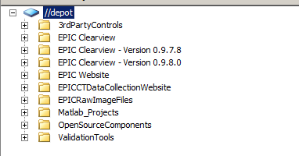
In this structure the branches for Clearview are are apparent. The current version always appears as an unlabeled (no version) entity called “EPIC Clearview”. After the branching process, it will appear as “EPIC Clearview – Version X.X.X.X”. This allows us at any time to be able to extract and reconstruct any version of the source code we desire.

  - Before creating the actual branch, be sure that all files necessary for the release have been checked into Perforce. There should be no open files when the branching takes place. Also verify that any new source files have been added to Perforce, this is a common mistake that can occur.

  - Perform file comparisons for the files that have changed to determine any other changes that may have been made outside of projects that have SRS. This list is helpful to QA, it allows them to tailor the testing to the things that have changed.

  - Verify that all DLL's are marked with the correct Assembly and File version, the version numbers should be same and match the branch version number for all EPIC created code.

  - The following steps are done to complete the branch:

    - Within Perforce in the depot view, select the current version of the Clearview code, it is the node labeled EPIC Clearview. Select the node and right click on it, this will display the context menu noted below.
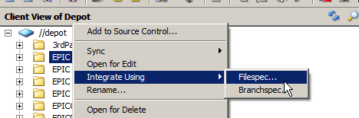
From the menu, select the Integrate → Filespec, this will display the integration dialog.

    - In the integration dialog, modify the field 'Target Filespec' to contain the location of the branch. In the example below, the X.X.X.X would be replaced with the actual version number.
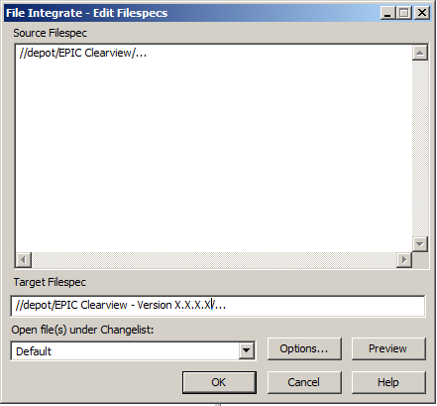
Click on the 'OK' button, this will create the structure of the branch, but will not actually move the files.

    - When the integration process is complete, you will need to submit the change list. The label for the submission should be 'Clearview Version X.X.X.X – Branch Creation'. Where X.X.X.X matches the version being branched.

    - The final step is to load the newly branched verison of code into Visual Studio and clean the solution. Then perform a build to verify that all files necessary for the release were properly branched. If the solution does not compile, locate the missing or errant files and add them to Perforce (this release) until the solution successfully builds.

- References

None.
Document Revision History
Change Order Number: | Version Number: | Description of Change: | Date: | Updated by:
CC-110523-01 | 000 | Introduction | 05/25/11 | A. Mason

